**Mechanical Fabrication of Nodes:**

What you will need:

1. Steminc ceramic cylinder
2. Pressure pot
3. PLA printing material
4. polyurethane WC-575A mixture from BJB enterprises
5. Rubber sheet
6. Screws and nuts
7. Access to 3D printer, soldering station, laser cutter

The main component of our transducer is a piezoelectric cylinder. We purchased a ceramic cylinder (fig. 1) from Steminc with an in-air resonance frequency of 17 kHz, a radius of 2.5 cm, and a length of 4 cm.

Purchase link :<https://www.steminc.com/PZT/en/piezo-ceramic-cylinder-541x47x40mm-17-khz>

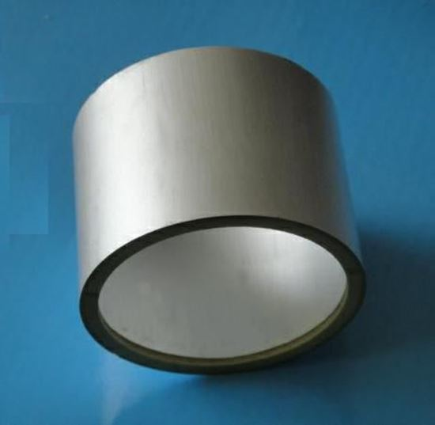

Fig. 1 Ceramic cylinder

**Procedure:**

1- First, we soldered two wires to the two electrodes of the piezoelectric ceramic (i.e., the inner and outer surfaces of the cylinder) as represented below.

Fig. 2 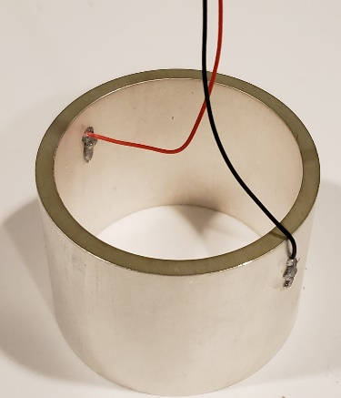

2- We 3D printed the base and the top cap from as well as a cylindrical mold to house the ceramic cylinder and encapsulation polymer.

Add the models for 3d printing

3-Then, we laser cut rubber washers and placed them on the top and bottom of the cylinder, then placed it on a base and added a top cap.

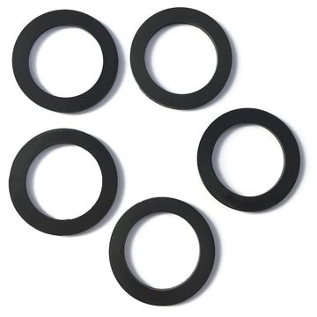

Fig3. Rubber washers

4- The setup is held tight using a screw and locking nut, then placed inside the mold.

Link for screws and nuts:

<https://www.homedepot.com/p/Everbilt-M3-5-Stainless-Steel-Metric-Hex-Nut-2-Piece-per-Bag-842318/204836105>

[https://www.homedepot.com/p/Everbilt-M3-0-5-x-20-mm-Phillips-Pan-Head-Stainless- Steel-Machine-Screw-2-Pack-842738/204283765](https://www.homedepot.com/p/Everbilt-M3-0-5-x-20-mm-Phillips-Pan-Head-Stainless-%20%20Steel-Machine-Screw-2-Pack-842738/204283765)

5- Finally, we prepared the encapsulation polymer, we used the polyurethane WC-575A/B mixture from BJB enterprises. The mix ratio by volume is A-100 B-94. We placed the mixture in a pressure pot at 60 (4atm) psi for at least 9 hours.

Pressure pot link: <https://www.smooth-on.com/products/pressure-chamber/>

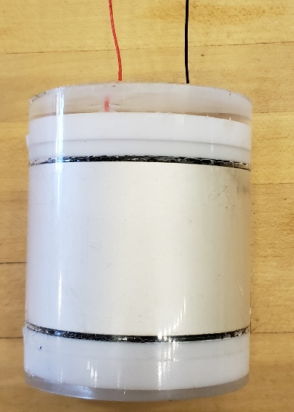

Fig 4. Final result